《机器学习基础》实验报告

年级、专业、班级 |  |  |  |  | 姓名
实验题目 | 决策树算法实践
实验时间 | 2020/12/05 |  | 实验地点 | DS3 303
实验成绩 |  |  | 实验性质 | □验证性 R设计性 □综合性
教师评价：
□算法/实验过程正确； □源程序/实验内容提交 □程序结构/实验步骤合理；
□实验结果正确； □语法、语义正确； □报告规范；
其他：
评价教师签名：
一、实验目的
掌握决策树回归算法原理。
二、实验项目内容
1.理解并描述决策树分类、回归算法原理。
2.编程实践，将决策树分类、回归算法分别应用于合适的数据集(如鸢尾花、波士顿房价预测、UCI数据集、Kaggle数据集)，要求算法至少用于两种数据集(分类2个，回归2个)。
三、实验过程或算法（源程序）
1.理解并描述决策树分类、回归算法原理。
（1）分类问题与回归问题：
数据分类分两个步骤：
- 构造模型，利用训练数据集训练分类器；
- 利用建好的分类器模型对测试数据进行分类。
好的分类器具有很好的泛化能力，即它不仅在训练数据集上能达到很高的正确率，而且能在未见过得测试数据集也能达到较高的正确率。如果一个分类器只是在训练数据上表现优秀，但在测试数据上表现稀烂，这个分类器就已经过拟合了，它只是把训练数据记下来了，并没有抓到整个数据空间的特征。
回归问题则与分类问题不同，回归问题是为了预测连续的标签值，也成为连续值。方法、评价指标与预估的模型都与分类问题有着很大的不同。

（2）决策树实现分类与回归问题的解决
在使用决策树作为分类模型的过程中，则针对上述出现的过拟合的问题，我们采取“剪枝”的方法来处理，本次实验中我采取了预剪枝与后剪枝两种方法进行处理，并且对比了预剪枝、后剪枝、不剪枝三种策略各自的分类准确率与计算的时间。决策树算法借助于树的分支结构实现分类。树的内部结点表示对某个属性的判断，该结点的分支是对应的判断结果；叶子结点代表一个类标。决策树算法有一个好处，那就是它可以产生人能直接理解的规则，这是贝叶斯、神经网络等算法没有的特性；决策树的准确率也比较高，而且不需要了解背景知识就可以进行分类，是一个非常有效的算法。决策树算法有很多变种，包括ID3、C4.5、CART等方法，但其基础都是类似的。本次实验中因为既要实现决策数回归，又要实现决策树分类，所以选择使用CART决策树，以基尼系数作为评判标准。
决策树的基本步骤分为：
- 选择划分标准
- 划分属性生成决策树
- 剪枝
具体过程：
- 构造一个节点N；
- 如果数据记录D中的所有记录的类标都相同（记为C类）：
- 则将节点N作为叶子节点标记为C，并返回结点N；
- 如果属性列表为空：
- 则将节点N作为叶子结点标记为D中类标最多的类，并返回结点N；
- 调用AttributeSelectionMethod(D,attributeList)选择最佳的分裂准则splitCriterion;
- 将节点N标记为最佳分裂准则splitCriterion;
- 如果分裂属性取值是离散的，并且允许决策树进行多叉分裂：
- 从属性列表中减去分裂属性，attributeLsit -= splitAttribute;
- 对分裂属性的每一个取值j:
- 记D中满足j的记录集合为Dj;
- 如果Dj为空：
- 则新建一个叶子结点F，标记为D中类标最多的类，并且把结点F挂在N下;
- 否则：
- 递归调用GenerateDecisionTree(Dj,attributeList)得到子树结点Nj，将Nj挂在N下;
- 返回结点N;
属性选择方法：
  - 信息增益：ID3
  - 信息增益率：C4.5
  - 基尼指数：CART

2.编程实践，将决策树分类、回归算法分别应用于合适的数据集(如鸢尾花、波士顿房价预测、UCI数据集、Kaggle数据集)，要求算法至少用于两种数据集(分类2个，回归2个)。
（1）项目结构与文件目录
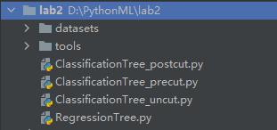
完成项目编写后，本次实验的文件结构如上图所示。具体的模型构建与训练过程以及模型代码编写思想将在下面详细说明。

（2）分类决策树模型构建
选择特征划分划分方法，计算基尼系数：
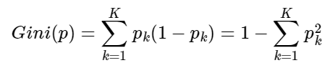
对给定的样本集合D，其基尼指数为：
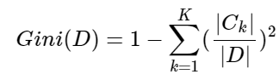
其中Ck是D中属于第k类的样本子集，K是类的个数，由于CART树是二叉树，所以对于某特征A，判断其对分类标签的贡献时，只需要判断该特征是否等于某个取值a的情况，将当前数据集分割成D1和D2两部分：
所以在特征A(x)=a的条件下，集合D的基尼指数，即集合D在特征A下的基尼指数可以定义为：
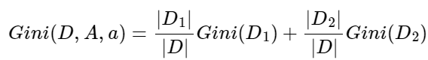
其中：

（3）使用Python实现上述模型
1) 不剪枝分类决策树数据获得与树的训练主函数
- import csv
- from tools.ClassificationTreeTools import *
- from time import *

- def run_test_un():
- f = open('datasets/Iris.csv', 'r')
- csvreader = csv.reader(f)
- final_list = list(csvreader)
- final_list_copy = final_list.copy()
- final_list = [t[1:5] for t in final_list]
- final_list[1:151] = [[float(num) for num in item] for item in final_list[1:151]]
- title = final_list[0]
- train_datas = []
- train_datas[0:0] = final_list[1:41]
- train_datas[len(train_datas):len(train_datas)] = final_list[51:91]
- train_datas[len(train_datas):len(train_datas)] = final_list[101:141]
- train_label = []
- train_label[0:0] = [t[5] for t in final_list_copy][1:41]
- train_label[len(train_label):len(train_label)] = [t[5] for t in final_list_copy][51:91]
- train_label[len(train_label):len(train_label)] = [t[5] for t in final_list_copy][101:141]

- test_datas = []
- test_datas[0:0] = final_list[41:51]
- test_datas[len(test_datas):len(test_datas)] = final_list[91:101]
- test_datas[len(test_datas):len(test_datas)] = final_list[141:151]
- test_label = []
- test_label[0:0] = [t[5] for t in final_list_copy][41:51]
- test_label[len(test_label):len(test_label)] = [t[5] for t in final_list_copy][91:101]
- test_label[len(test_label):len(test_label)] = [t[5] for t in final_list_copy][141:151]
- train_data = []
- test_data = []
- for data_record in train_datas:
- a_dict = {}
- dim = len(data_record) - 1
- for i in range(0, dim+1):
- a_dict[title[i]] = data_record[i]
- train_data.append(a_dict)
- # train_label.append(data_record[dim])
- for data_record in test_datas:
- a_dict = {}
- dim = len(data_record) - 1
- for i in range(0, dim+1):
- a_dict[title[i]] = data_record[i]
- test_data.append(a_dict)
- # test_label.append(data_record[dim])
- begin_time = time()
- decision_tree = cart_tree(train_data, title, train_label)
- end_time = time()
- run_time = end_time - begin_time
- print('运行时间：', run_time)

- print('决策树是:')
- print_tree(decision_tree)
- print('\n')

- test_judge = []
- for data_record in test_data:
- test_judge.append(classify_data(decision_tree, data_record))
- print('决策树在测试数据集上的分类结果是：', test_judge)
- print('测试数据集的正确类别信息应该是： ', test_label)

- accuracy = 0
- for i in range(0, len(test_label)):
- if test_label[i] == test_judge[i]:
- accuracy += 1
- accuracy /= len(test_label)
- print('决策树在测试数据集上的分类正确率为：' + str(accuracy * 100) + "%")

- if __name__ == '__main__':
- run_test_un()
2) 后剪枝分类决策树数据获得与树的训练主函数
- import csv
- from tools.ClassificationTreeTools import *
- from time import *

- def run_test_post(): # 后剪枝
- f = open('datasets/Iris.csv', 'r')
- csvreader = csv.reader(f)
- final_list = list(csvreader)
- final_list_copy = final_list.copy()
- final_list = [t[1:5] for t in final_list]
- final_list[1:151] = [[float(num) for num in item] for item in final_list[1:151]]
- title = final_list[0]
- train_datas = []
- train_datas[0:0] = final_list[1:41]
- train_datas[len(train_datas):len(train_datas)] = final_list[51:91]
- train_datas[len(train_datas):len(train_datas)] = final_list[101:141]
- train_label = []
- train_label[0:0] = [t[5] for t in final_list_copy][1:41]
- train_label[len(train_label):len(train_label)] = [t[5] for t in final_list_copy][51:91]
- train_label[len(train_label):len(train_label)] = [t[5] for t in final_list_copy][101:141]

- test_datas = []
- test_datas[0:0] = final_list[41:51]
- test_datas[len(test_datas):len(test_datas)] = final_list[91:101]
- test_datas[len(test_datas):len(test_datas)] = final_list[141:151]
- test_label = []
- test_label[0:0] = [t[5] for t in final_list_copy][41:51]
- test_label[len(test_label):len(test_label)] = [t[5] for t in final_list_copy][91:101]
- test_label[len(test_label):len(test_label)] = [t[5] for t in final_list_copy][141:151]

- train_data = []
- test_data = []
- for data_record in train_datas:
- a_dict = {}
- dim = len(data_record) - 1
- for i in range(0, dim+1):
- a_dict[title[i]] = data_record[i]
- train_data.append(a_dict)
- for data_record in test_datas:
- a_dict = {}
- dim = len(data_record) - 1
- for i in range(0, dim+1):
- a_dict[title[i]] = data_record[i]
- test_data.append(a_dict)
- begin_time = time()
- decision_tree = cart_tree(train_data, title, train_label)
- post_pruning(decision_tree=decision_tree, test_data=test_data, test_label=test_label,train_label=train_label)
- end_time = time()
- run_time = end_time - begin_time
- print('运行时间：', run_time)
- print('剪枝之后的决策树是:')
- print_tree(decision_tree)
- print('\n')

- test_judge = []
- for data_record in test_data:
- test_judge.append(classify_data(decision_tree, data_record))
- print('决策树在测试数据集上的分类结果是：', test_judge)
- print('测试数据集的正确类别信息应该是： ', test_label)

- accuracy = 0
- for i in range(0, len(test_label)):
- if test_label[i] == test_judge[i]:
- accuracy += 1
- accuracy /= len(test_label)
- print('决策树在测试数据集上的分类正确率为：' + str(accuracy * 100) + "%")

- if __name__ == '__main__':
- run_test_post()
3) 预剪枝分类决策树数据获得与树的训练主函数
- import csv
- from tools.ClassificationTreeTools import *
- from time import *

- def run_test_pre(): # 前剪枝
- f = open('datasets/Iris.csv', 'r')
- csvreader = csv.reader(f)
- final_list = list(csvreader)
- final_list_copy = final_list.copy()
- final_list = [t[1:5] for t in final_list]
- final_list[1:151] = [[float(num) for num in item] for item in final_list[1:151]]
- title = final_list[0]
- train_datas = []
- train_datas[0:0] = final_list[1:41]
- train_datas[len(train_datas):len(train_datas)] = final_list[51:91]
- train_datas[len(train_datas):len(train_datas)] = final_list[101:141]
- train_label = []
- train_label[0:0] = [t[5] for t in final_list_copy][1:41]
- train_label[len(train_label):len(train_label)] = [t[5] for t in final_list_copy][51:91]
- train_label[len(train_label):len(train_label)] = [t[5] for t in final_list_copy][101:141]

- test_datas = []
- test_datas[0:0] = final_list[41:51]
- test_datas[len(test_datas):len(test_datas)] = final_list[91:101]
- test_datas[len(test_datas):len(test_datas)] = final_list[141:151]
- test_label = []
- test_label[0:0] = [t[5] for t in final_list_copy][41:51]
- test_label[len(test_label):len(test_label)] = [t[5] for t in final_list_copy][91:101]
- test_label[len(test_label):len(test_label)] = [t[5] for t in final_list_copy][141:151]
- train_data = []
- test_data = []
- for data_records in train_datas:
- a_dict = {}
- dim = len(data_records) - 1
- for i in range(0, dim+1):
- a_dict[title[i]] = data_records[i]
- train_data.append(a_dict)
- # train_label.append(data_records[dim])
- for data_records in test_datas:
- a_dict = {}
- dim = len(data_records) - 1
- for i in range(0, dim+1):
- a_dict[title[i]] = data_records[i]
- test_data.append(a_dict)
- # test_label.append(data_records[dim])

- begin_time = time()
- decision_tree = precut_cart_tree(train_data, title, train_label, test_data, test_label)
- end_time = time()
- run_time = end_time - begin_time
- print('运行时间：', run_time)

- print('训练的决策树是:')
- print_tree(decision_tree)
- print('\n')

- test_judge = []
- for data_records in test_data:
- test_judge.append(classify_data(decision_tree, data_records))
- print('决策树在测试数据集上的分类结果是：', test_judge)
- print('测试数据集的正确类别信息应该是： ', test_label)

- accuracy = 0
- for i in range(0, len(test_label)):
- if test_label[i] == test_judge[i]:
- accuracy += 1
- accuracy /= len(test_label)
- print('决策树在测试数据集上的分类正确率为：' + str(accuracy * 100) + "%")

- if __name__ == '__main__':
- run_test_pre()
4) 分类决策树工具文件中的部分函数
- def continuous(s): # 判断数据属性是否连续
- try:
- float(s)
- return True
- except ValueError:
- pass
- return False

- def cart_tree(Data, title, label):
- n = len(Data)
- root_data = []
- for i in range(0, n):
- root_data.append(i)
- root_node = TreeNode(data_index=root_data, rest_attribute=title.copy())
- finish_node(root_node, Data, label)
- return root_node

- def precut_cart_tree(Data, title, label, test_data, test_label):
- n = len(Data)
- root_data = []
- for i in range(0, n):
- root_data.append(i)

- root_node = TreeNode(data_index=root_data, rest_attribute=title.copy())
- finish_node_pre(root_node, Data, label, test_data, test_label)
- return root_node

- def post_pruning(decision_tree, test_data=[], test_label=[], train_label=[]):
- leaf_father = [] # 所有的孩子都是叶结点的结点集合
- iteration_list = []
- iteration_list.append(decision_tree)
- while len(iteration_list) > 0:
- current_node = iteration_list[0]
- children = current_node.children
- wanted = True # 判断当前结点是否满足所有的子结点都是叶子结点
- if not (children is None):
- for child in children:
- iteration_list.append(child)
- temp_bool = (child.children is None)
- wanted = (wanted and temp_bool)
- else:
- wanted = False

- if wanted:
- leaf_father.append(current_node)
- iteration_list.remove(current_node)

- while len(leaf_father) > 0:
- # 如果叶父结点为空，则剪枝完成。对于不需要进行剪枝操作的叶父结点，我们也之间将其从leaf_father中删除
- current_node = leaf_father.pop()
- # 不进行剪枝在测试集上的正确率
- before_accuracy = current_accuracy(root_node=decision_tree, test_data=test_data, test_label=test_label)

- data_index = current_node.data_index
- label_count = {}
- for index in data_index:
- if label_count.__contains__(index):
- label_count[train_label[index]] += 1
- else:
- label_count[train_label[index]] = 1
- current_node.verdiction = max(label_count, key=label_count.get) # 如果进行剪枝当前结点应该做出的判断
- later_accuracy = current_accuracy(root_node=decision_tree, test_data=test_data, test_label=test_label)

- if before_accuracy > later_accuracy: # 不进行剪枝
- current_node.verdiction = None
- else: # 进行剪枝
- current_node.children = None
- # 还需要检查是否需要对它的父节点进行判断
- parent_node = current_node.parent
- if not (parent_node is None):
- children_list = parent_node.children
- temp_bool = True
- for child in children_list:
- if not (child.children is None):
- temp_bool = False
- break
- if temp_bool:
- leaf_father.append(parent_node)

- def print_tree(root=TreeNode):
- node_list = [root]
- while (len(node_list) > 0):
- current_node = node_list[0]
- print('--------------------------------------------')
- print(current_node.to_string())
- print('--------------------------------------------')
- children_list = current_node.children
- if not (children_list is None):
- for child in children_list:
- node_list.append(child)
- node_list.remove(current_node)

- def classify_data(decision_tree=TreeNode, x={}):
- current_node = decision_tree
- while current_node.verdiction is None:
- if current_node.split is None:
- can_judge = False
- for child in current_node.children:
- if child.attribute_value == x[current_node.attribute_name]:
- current_node = child
- can_judge = True
- break
- if not can_judge:
- return None
- else:
- child_list = current_node.children
- if x[current_node.attribute_name] <= current_node.split:
- current_node = child_list[0]
- else:
- current_node = child_list[1]

- return current_node.verdiction

（3）回归决策树模型构建
回归树的特征选择是使用的平方误差，即选择一个特征j和一个取值s,将训练集按Xj≤s和Xj>s分为两部分，寻找使这两部分的误差平方之和下降最多的j,s，这个过程可以描述如下：
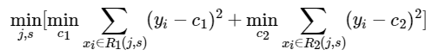
其中：
（4）使用Python实现上述模型
1) 不剪枝回归决策树
- import numpy as np
- from collections import Counter
- import pandas as pd
- from tools.RegressionTreeTools import *

- def training(dataset, feature_label=None):
- dataset = np.array(dataset)
- targets = dataset[:, -1]
- if np.unique(targets).shape[0] == 1:
- return targets[0]
- if dataset.shape[1] == 1:
- return Counter(targets.tolist()).most_common(1)[0]
- if feature_label is None:
- feature_label = [i for i in range(dataset.shape[1] - 1)]

- best_feature, best_value = choose_best_feature(dataset)
- best_feature_label = feature_label[best_feature]
- mytree = dict()
- mytree['FeatLabel'] = best_feature_label
- mytree['FeatValue'] = best_value
- l_set, r_set = split_dataset(dataset, best_feature, best_value)
- mytree['left'] = training(l_set, feature_label)
- mytree['right'] = training(r_set, feature_label)
- return mytree

- def predict(tree, test_data, feature_label=None):
- if not isinstance(tree, dict):
- return tree
- if feature_label is None:
- feature_label = [i for i in range(test_data.shape[1] - 1)]

- best_feature_label = tree['FeatLabel']
- best_feature = feature_label.index(best_feature_label)
- if test_data[best_feature] <= tree['FeatValue']:
- return predict(tree['left'], test_data, feature_label)
- else:
- return predict(tree['right'], test_data, feature_label)

- if __name__ == '__main__':
- student = np.delete(np.array(pd.read_csv('datasets/student_admit.csv')), 0, axis=1)
- print(training(student))

- housing = np.delete(np.array(pd.read_csv('datasets/boston_housing.csv')), 0, axis=1)
- print(training(housing))
2) 不剪枝回归决策树工具文件部分函数
- def cal_se(dataset):
- return np.var(dataset[:, -1]) * dataset.shape[0] if dataset.shape[0] > 0 else 0

- def split_dataset(dataset, feature, value):
- left = dataset[np.nonzero(dataset[:, feature] <= value)[0], :]
- right = dataset[np.nonzero(dataset[:, feature] > value)[0], :]
- return left, right

- def cal_split_se(dataset, feature):
- values = np.unique(dataset[:, feature])
- min_se, min_value = np.inf, 0
- for value in values:
- left, right = split_dataset(dataset, feature, value)
- new_se = cal_se(left) + cal_se(right)
- if new_se < min_se:
- min_se = new_se
- min_value = value
- return min_se, min_value

- def choose_best_feature(dataset):
- m, n = dataset.shape[0], dataset.shape[1] - 1
- delta_gini, delta_info = np.inf, -np.inf
- best_feature, best_value = -1, 0
- for feature in range(n):
- new_se, value = cal_split_se(dataset, feature)
- if new_se < delta_gini:
- delta_gini = new_se
- best_value = value
- best_feature = feature
- return best_feature, best_value

（5）完成决策树编写，选取数据集进行测试：
分类数据集：鸢尾花数据集；动物园分类数据集
回归数据集：学生录取概率数据集；波士顿房价数据集
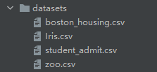

四、实验结果及分析
（1）鸢尾花分类数据集
1) 不剪枝分类决策树
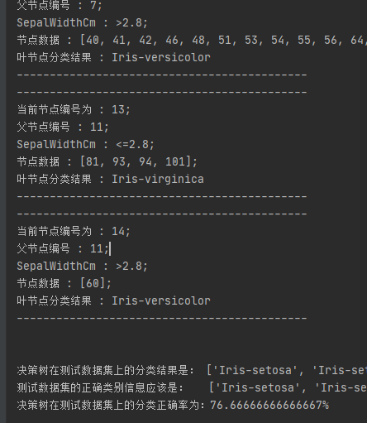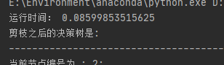
2) 后剪枝分类决策树
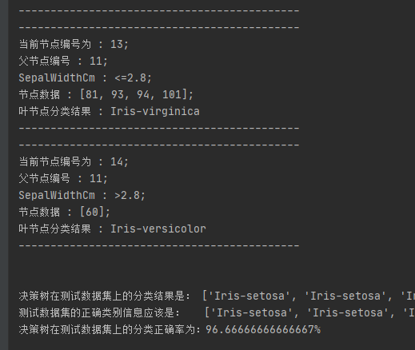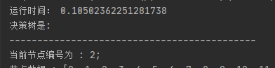
3) 预剪枝分类决策树
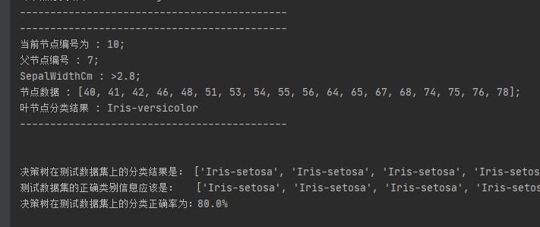
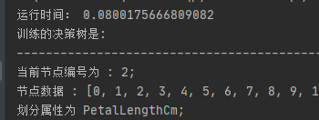
（2）动物园分类数据集
1) 不剪枝分类决策树
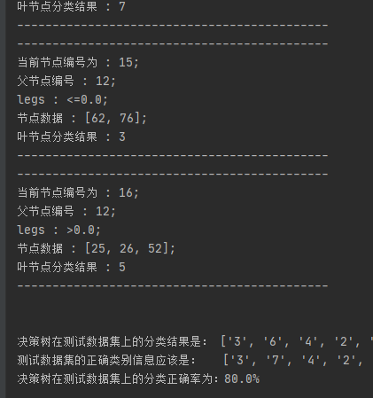
2) 后剪枝分类决策树
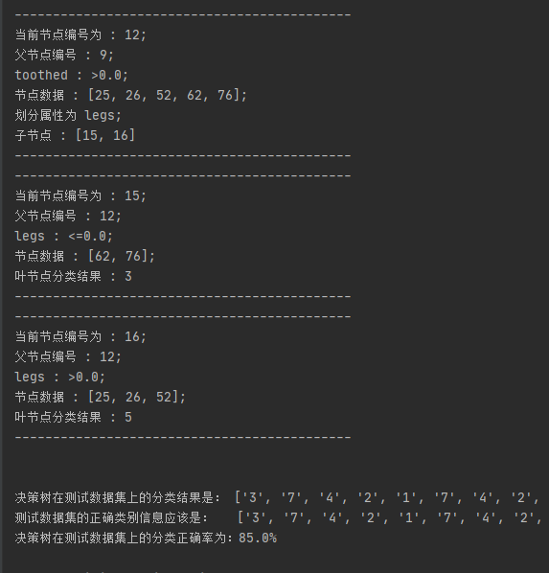
3) 预剪枝分类决策树
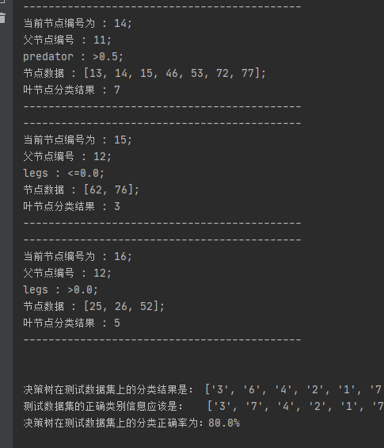
可以看出不剪枝准确率最低，预剪枝准确率较高，训练时间最少，后剪枝准确率最高，训练时间最长。

（3）波士顿房价回归数据集
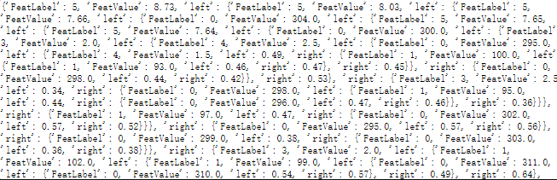
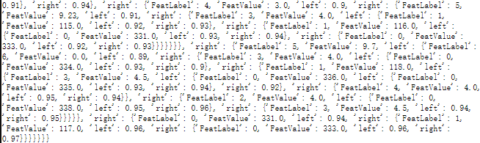

（4）学生录取概率预测回归数据集
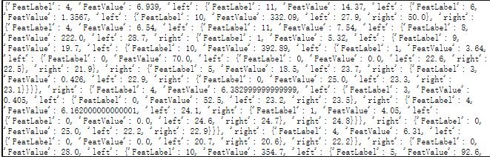
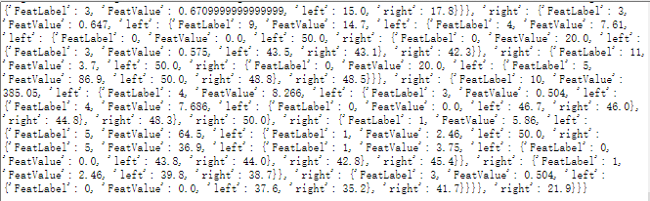

（5）实验结果分析
由以上运行结果截图可知本次实验的模型实现正确，效果良好。

